Task 1:
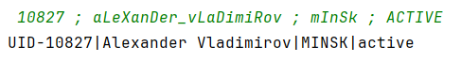
Task 2:
Task 3:
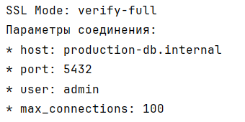
Task 4:
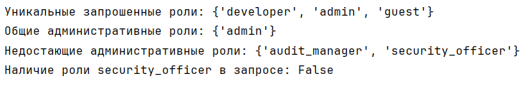
Task 5:
